Strings are mostly used

So, we may need to sort them on various situations

Like as properties in objects, items in arrays and in many other places

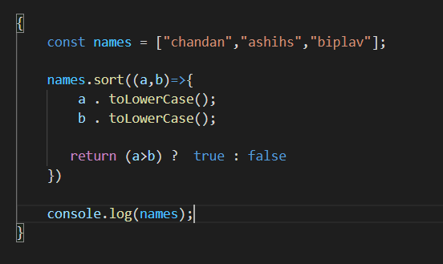

However

FOR ARRAY

doing just names.sort() does job

But above method is the fundamental to sort ordered sequence of strings at any situations